

**The Anxiety Toolkit**

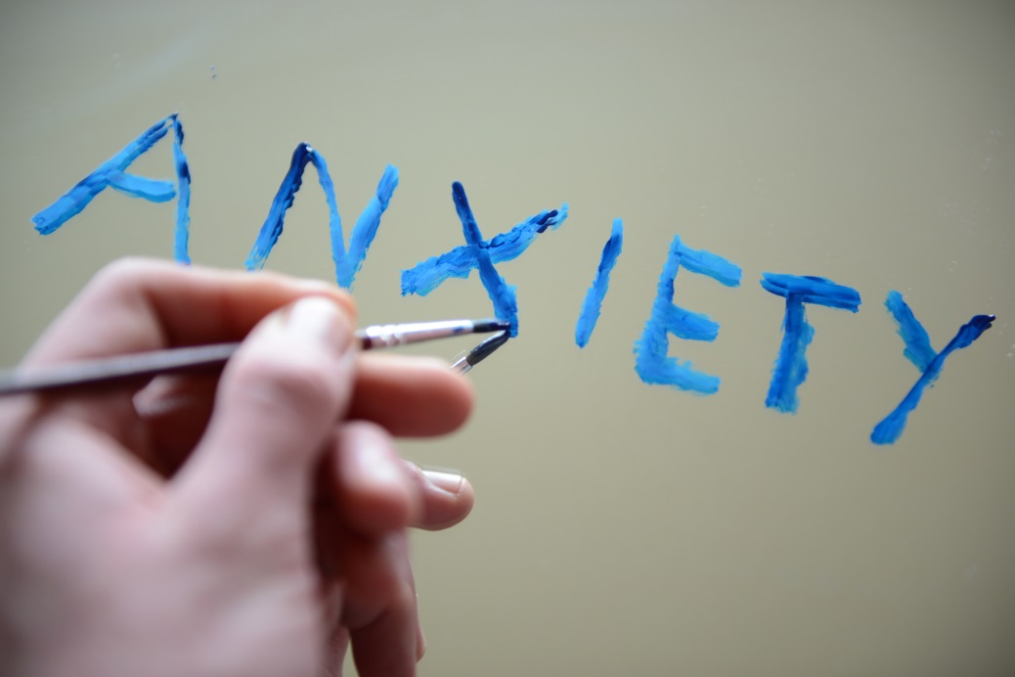

**A multi-agency guide to addressing emerging anxiety in children and   
young people in Hertfordshire**

**Contents**

**1. Background**

**2. Evidence of need**

**3. Resources for whole school approaches;**

3.1 Hertfordshire guidance

3.2 Hertfordshire Kite Mark

3.3 Mental Health Leads Toolkit

3.4 Training

3.5 MindEd eLearning modules

3.6 Staff wellbeing

**4. Resources**

4.1 Network and school resources

4.2 Understanding, monitoring and supporting emerging anxiety

4.3 Presentations

4.4 Parents

**1. Background**

A multi-agency working group was convened by Hertfordshire’s two NHS Clinical Commissioning Groups; East & North Herts and Herts Valleys, to create a resource on anxiety. The professionals in the group came from the following agencies: Clinical Commissioning Groups, Public Health, Education Support for Medical Absence (ESMA), School Attendance, Schools, child and adolescent mental health services (CAMHS) provider Hertfordshire Partnership University NHS Foundation Trust (HPFT), local school partnerships, Hertfordshire Community NHS Trust’s (HCT) School Nursing Service, Educational Psychology and parent representatives.

Responding to the increased issue of anxiety amongst school aged children; the group was set up to look at ways in which support could be offered to children and young people, parents and schools. It is important to highlight that anxiety is normal but can become a problem if it starts to get in the way of day to day life.

It was decided that the toolkit should be created to help stop unnecessary distress and escalation of anxiety levels in children and young people, which will help to improve their educational and life outcomes.

The toolkit takes the form of a range of resources which are being shared with schools to help them to support staff, pupils and parents. Each resource will have instructions for use.

The toolkit will be hosted on the Healthy Young Minds in Herts website in the school professionals’ area.

<https://www.healthyyoungmindsinherts.org.uk/schools>

Please note, to access this resource, you will need to register to access the school mental health lead toolkit. You can register here:

https://www.healthyyoungmindsinherts.org.uk/user/register

**2. Evidence of need**

Everyone experiences anxiety at some point in their life when they are apprehensive or unsure about a situation or event. It is a very common part of life. It is a normal physical response to a given situation which our mind and body are reacting to.

Anxiety is considered a normal and adaptive emotion when it serves to improve a person’s functioning or wellbeing. For example, having increased heart rate and adrenaline rush before a race or going on stage.

In contrast, anxiety is problematic when it is a chronic condition that impairs a person’s functioning and interferes with their wellbeing. This impairment can cause significant distress. It can affect their ability to perform normal tasks, for example, not being able to leave the house.

Anxiety can be caused by several factors including a change in environment or stress. Parents can sometimes unwittingly project their own anxieties on to their children. Anxiety can be missed. It is important to consider underlying reasons for behaviour to be able to help reduce anxiety levels.

Recent research suggests that 1 in 6 young people will experience an anxiety issuesat some point in their lives, whether that be OCD (obsessive compulsive disorder), social anxiety, exam stress, worry or panic attacks. (Anxietyuk.org.uk, 2017)

Around 75% of mental health problems in adult life (not including dementia) start by the age of 18. Not supporting children and young people with their mental health costs lives and money. Early help stops young people falling into crisis and avoids expensive and longer-term treatment in adulthood. (Future in Mind: promoting, protecting and improving our children and young people’s mental health and wellbeing. Dept. of Health 2015)

One in 10 children aged between 5 and 16 years has a diagnosable mental health problem, and a further 15% are potentially at risk.

Academic tests are identified as a major source of concern to many children, and the overall prevalence of test anxiety appears to be increasing, possibly due to increased testing in schools and pressures associated with this. (McDonald 2010)

Hertfordshire’s 2016 Health-Related Behaviour Questionnaire, found exams and bullying are key areas of worry for children and young people.

Definition of anxiety

1. A feeling of worry, nervousness, or unease about something with an uncertain outcome.

1.1 Psychiatry: A nervous disorder marked by excessive uneasiness and apprehension, typically with compulsive behaviour or panic attacks.

2. [with infinitive] Strong desire or concern to do something or for something to happen.

(Oxford Dictionary)

DSM-V

The Diagnostic and Statistical Manual of Mental Disorders (DSM) is the reference book used by medical and mental health professionals to diagnose mental conditions. The medical categorisations of anxiety disorders are listed in DSM-V and are in three separate categories, which are:

1. Anxiety Disorders (separation anxiety disorder, selective mutism, specific phobia, social phobia, panic disorder, agoraphobia, and generalised anxiety disorder).

2. Obsessive-Compulsive Disorders (obsessive-compulsive disorder, body dysmorphic disorder, hoarding disorder, trichotillomania, and excoriation disorder).

3. Trauma and Stressor-Related Disorders (reactive attachment disorder, disinhibited social engagement disorder, PTSD, acute stress disorder, and adjustment disorder).

Gender differences

It is important to recognise that anxiety can present in different ways within boys and girls. Often boys’ anxiety is exhibited through disruptive behaviour and is not always recognised as anxiety, but as bad behaviour. Therefore, it should be noted that different approaches may be needed when working with boys and girls.

**3. Resources for Whole School Approaches**

3.1 Hertfordshire Schools Self Review; Whole School Approach to Mental Health and Emotional Wellbeing

The purpose of this document is to support schools to develop their own whole school approach to improving mental health and emotional wellbeing. There are a number of frameworks that exist and this document gives some background on each so you can decide which ones will be most helpful to the approach you want to take.

As schools find themselves increasingly responding to the mental health difficulties of staff, parents and pupils, the whole school, early intervention approach has never been so needed. This document supports a renewed effort to improve, consolidate or review our early help and prevention within schools.

Schools ask – “Are we doing enough?” This document lists approaches, interventions, resources, practice and tools within the local context.

The full review document can be found at:

<https://www.healthyyoungmindsinherts.org.uk/schools/mental-health-leads-toolkit>

Please note, to access this resource, you will need to register to access the school mental health lead toolkit. You can register here:

https://www.healthyyoungmindsinherts.org.uk/user/register

3.2 Hertfordshire School Kite Mark (to be launched in Summer 2018)

The Healthy Young Minds in Herts School Accreditation process will enable schools to achieve kite mark status for their contribution to supporting mental health and wellbeing. It will help to ensure a consistent approach to school-based competency in relation to mental health and wellbeing. The Suicide Aware Schools Status award contains some additional requirements for schools to demonstrate a commitment to reducing suicide.

All accreditation processes and application can be found at;

<https://www.healthyyoungmindsinherts.org.uk/schools>

3.3 Mental Health Leads Toolkit

Created as part of the CAMHS Transformation, [www.healthyyoungmindsinherts.org.uk](http://www.healthyyoungmindsinherts.org.uk) features a wealth of information for young people, parents and carers and professionals working with children and young people.

There are great resources for schools in a password-protected area, including the latest Mental Health Leads toolkit, lesson plans and a forum to share best practice. To register, visit [www.healthyyoungmindsinherts.org.uk/schools](http://www.healthyyoungmindsinherts.org.uk/schools) click on the link ‘To access schools forum you must be [logged in](http://www.healthyyoungmindsinherts.org.uk/user/)’ underneath the menu on the left hand side. Click on the new user tab, fill out the form and your account will be sent for approval.

The forum and tools for mental health leads contain resources which we have secured permission to use locally so you will need to register to access this section. Anyone in a Hertfordshire school can register to use the section. The website is always being updated but here is a selection of what you can find in the tools for mental health leads section:

* Training slides
* Videos
* Explainers
* Referral forms
* Recording and assessment tools
* Early identification processes
* Information about services
* Links to guidance

In another part of the website, there are tips for talking to teens for parents and carers.

3.4 Training

There are various types of training on offer to school staff and parents which can support their knowledge and skills when dealing with a child or young person with anxiety. Courses that have run in the past included; Anxiety Awareness, Mental Health First Aid Youth and Solution Focused Reflective Practice.

Please follow the link to access the information on the training which is currently available.

<https://www.healthyyoungmindsinherts.org.uk/schools/emotional-wellbeing-training-school-staff>

3.5 MindEd eLearning Modules

The Department of Health’s online learning tool has a huge number of eLearning modules on emotional health and wellbeing issues to support professionals working with children and young people. Each module is approximately 30 minutes.

Suggested modules on anxiety include;

* The Worried Child
* Avoiding School and Social Isolation
* The Loner
* Refusal to go to school

All modules are available through the search function at:

<https://www.minded.org.uk/Catalogue/TileView>

3.6 Staff wellbeing

Teen mental health is a high priority, with many charitable and government initiatives intended to address escalating rates of depression and anxiety in this population.

Whilst this is to be welcomed, what’s less well publicised is the prevalence of similar challenges amongst teachers. Repeated surveys show anywhere between 50% and 75% of teachers are experiencing stress, anxiety, depression and overwhelm, creating a cycle of reduced performance, guilt, low mood and low self-esteem.

The Wellbeing Service is a free NHS service in Hertfordshire, offering structured support to adults experiencing these types of mental health problem. The service works with a range of groups and provides flexible, short-term interventions. If you’re a teacher registered with a Hertfordshire GP, the Wellbeing Service can help you manage boundaries, increase assertiveness, develop coping strategies and find a way forward. To self-refer, simply visit [www.talkwellbeing.co.uk](http://www.talkwellbeing.co.uk)

**4. Resources**

The resources which are available as part of this toolkit are listed below in sections. These resources have been recommended for use by professionals working in the field.

There are self-help tools to help you work with a child or young person and for the young person to use themselves.

Presentations/workshops can be delivered by schools with the resources provided.

Each resource has a user guide and instructions explaining how and when the resource should best be used. An example of the user guide is shown below.

|  |  |  |
| --- | --- | --- |
| **User guide** | | |
| **Age** | Primary school children |  |
| **Audience** | Children |  |
| **Level of need** | Basic anxiety |  |
| **Type of intervention** | 1-2-1 work with child |  |
| **Number of people** | 1 |  |

4.1 Network and School resources

* Pastoral Leads Groups run in each district across the county for all secondary schools and is being trialled in some districts for primary schools. To find your nearest group, please contact [PublicHealth@hertfordshire.gov.uk](mailto:PublicHealth@hertfordshire.gov.uk)

4.2 Understanding, monitoring and supporting emerging

anxiety

* [Anxiety Mapping Guidance](https://www.healthyyoungmindsinherts.org.uk/publications/2018/mar/anxiety-mapping-guidance)
* [Leaflet for secondary school age pupils](https://www.healthyyoungmindsinherts.org.uk/publications/2018/may/anxiety-resources)
* [Anxiety Card](https://www.healthyyoungmindsinherts.org.uk/publications/2018/apr/anxiety-card)
* [Five Ways to Wellbeing](https://www.healthyyoungmindsinherts.org.uk/five-ways-wellbeing)
* [Stress Bucket Activity](https://www.healthyyoungmindsinherts.org.uk/publications/2017/dec/stress-bucket-activity)
* [SAM (Self-help for Anxiety Management) Interactive games and tools app](https://www.healthyyoungmindsinherts.org.uk/publications/2018/apr/apps-anxiety)
* [MindShift™app](https://www.healthyyoungmindsinherts.org.uk/publications/2018/apr/apps-anxiety)
* [Huge Bag of Worries and What’s in your bag of worries](https://www.healthyyoungmindsinherts.org.uk/publications/2018/apr/anxiety-resources)
* Early Intervention – check in card
* [My solution plan](https://www.healthyyoungmindsinherts.org.uk/publications/2018/apr/anxiety-resources)
* [Small steps to success](https://www.healthyyoungmindsinherts.org.uk/publications/2018/apr/anxiety-resources)
* [Goal progress chart](https://www.healthyyoungmindsinherts.org.uk/publications/2018/apr/anxiety-resources)
* [PowerUp. A resource from the Anna Freud Centre](https://www.createmarketing.co.uk/works/anna-freud-centre-healthcare-app-development/)
* [Shelf Help](https://www.healthyyoungmindsinherts.org.uk/publications/2017/jan/shelf-help-support-and-advice-you) – a series of books designed for children and young people to support their emotional health and wellbeing, available in Hertfordshire libraries <http://reading-well.org.uk/>
* [Lazy River – Mindfulness exercise](https://www.healthyyoungmindsinherts.org.uk/publications/2018/apr/mindfulness-exercises-schools)
* [What do you worry about? – Mindfulness exercise](https://www.healthyyoungmindsinherts.org.uk/publications/2018/apr/mindfulness-exercises-schools)
* [Blank White Board – Mindfulness exercise](https://www.healthyyoungmindsinherts.org.uk/publications/2018/apr/mindfulness-exercises-schools)

***Please note;*** *the resources provided in this section are not intended to be used one by one with each child. They are a range of resources which you can choose from depending on the child’s needs and the support required.* ***Instructions and guidance for each resource are available under Resource section 4.0***

4.3 Presentations

* Mental Health presentations for schools

These include;

* + [Exam stress workshop for parents (secondary)](https://www.healthyyoungmindsinherts.org.uk/publications/2018/may/anxiety-lessons-and-presentations)
  + [Emotional health and wellbeing workshop for parents](https://www.healthyyoungmindsinherts.org.uk/publications/2018/may/anxiety-lessons-and-presentations)

4.4 Parents

* [Top tips for Parents series](http://www.healthyyoungmindsinherts.org.uk/anxiety-toolkit)

Topic areas;

* 1. [Five ways to wellbeing](https://www.healthyyoungmindsinherts.org.uk/publications/2018/mar/parent-tip-no-1-five-ways-wellbeing)
  2. [Managing anxiety for over-16s](https://www.healthyyoungmindsinherts.org.uk/publications/2018/mar/parent-tip-no-2-managing-anxiety-over-16s)
  3. [How to stay emotionally healthy and support your child’s emotional wellbeing](https://www.healthyyoungmindsinherts.org.uk/publications/2018/mar/parent-tip-no-3-how-stay-emotionally-healthy)
  4. [How to help your child manage their anxiety during exams and tests](https://www.healthyyoungmindsinherts.org.uk/publications/2018/mar/parent-tip-no-4-how-help-your-child-manage-their-anxiety-during-exams-and)
  5. [Listening to your child](https://www.healthyyoungmindsinherts.org.uk/publications/2018/mar/parent-tip-no-5-listening-your-child)
  6. [Sleep](https://www.healthyyoungmindsinherts.org.uk/publications/2018/mar/parent-tip-no-6-sleep)
  7. [Autism and anxiety](https://www.healthyyoungmindsinherts.org.uk/publications/2018/apr/parent-tip-no-7-autism-and-anxiety)
* Parent Support Groups for Anxiety

The Carers in Herts support network for parents of CYP attending HPFT CAMHS or Step 2. Contact <http://www.carersinherts.org.uk/>

**Further information or support**

Please contact:

Breda O’Neill, CAMHS Schools Link Manager, East & North Herts Clinical Commissioning Group at

[Breda.O'Neill@nhs.net](mailto:Breda.O'Neill@nhs.net)

or

Shelley Taylor, Public Health Officer, Hertfordshire County Council at

[Shelley.Taylor@hertfordshire.gov.uk](mailto:Shelley.Taylor@hertfordshire.gov.uk)