Stress Bucket Activity

|  |  |  |
| --- | --- | --- |
| **Age Level of need** | Primary/Secondary/SEN | Can be adapted for younger children and children/young people with SEN – make a felt bucket, put pictures/drawings of worries in the bucket |
| **Audience** | Parents / Children and young people |  |
| **Type of intervention** | Can be used by teachers/parents as a self-help for a child or young person. Can also be used by a young person a lot as a self-help tool | To be completed with child/young person or parent following explanation of the Stress bucket concept of how each individual manages stress/Anxiety. Part of on going work around awareness of stress/Anxiety levels and using healthy coping strategies. |
| **Number of people** | Individual or group |  |

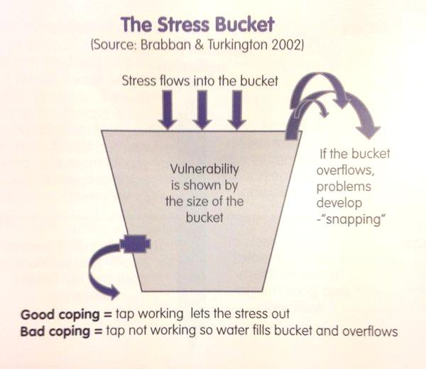

**Stress bucket activity**

Discuss the diagram above, note the tap or release valve which is a metaphor for coping skills.

First think about the size of the bucket – the worksheet enables you to choose a size to reflect how vulnerable the person feels they are in relation to managing the stresses in their life.

Secondly, ask the young person to think about the things that could go in the bucket, all the things that contribute the stress in their life.

Thirdly, ask the following questions or ask the young person to ask themselves:

1. Do you have any evidence to support your feelings?

2. What can you change?

3. What can’t you change and need to accept?

4. What needs your urgent attention?

5. Can anyone help you?

Finally, ask the young person to consider the helpful and unhelpful coping strategies that they employ. Are there any unhelpful strategies that they could reduce and any helpful ones they could increase?

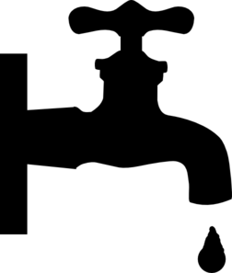

Helpful coping strategies

Unhelpful coping strategies

**Stress Bucket**

1. Do I have any evidence to support my feelings?

2. What can I change?

3. What can’t I change and need to accept?

4. What needs my urgent attention?

5. Who can help me?

Helpful coping strategies