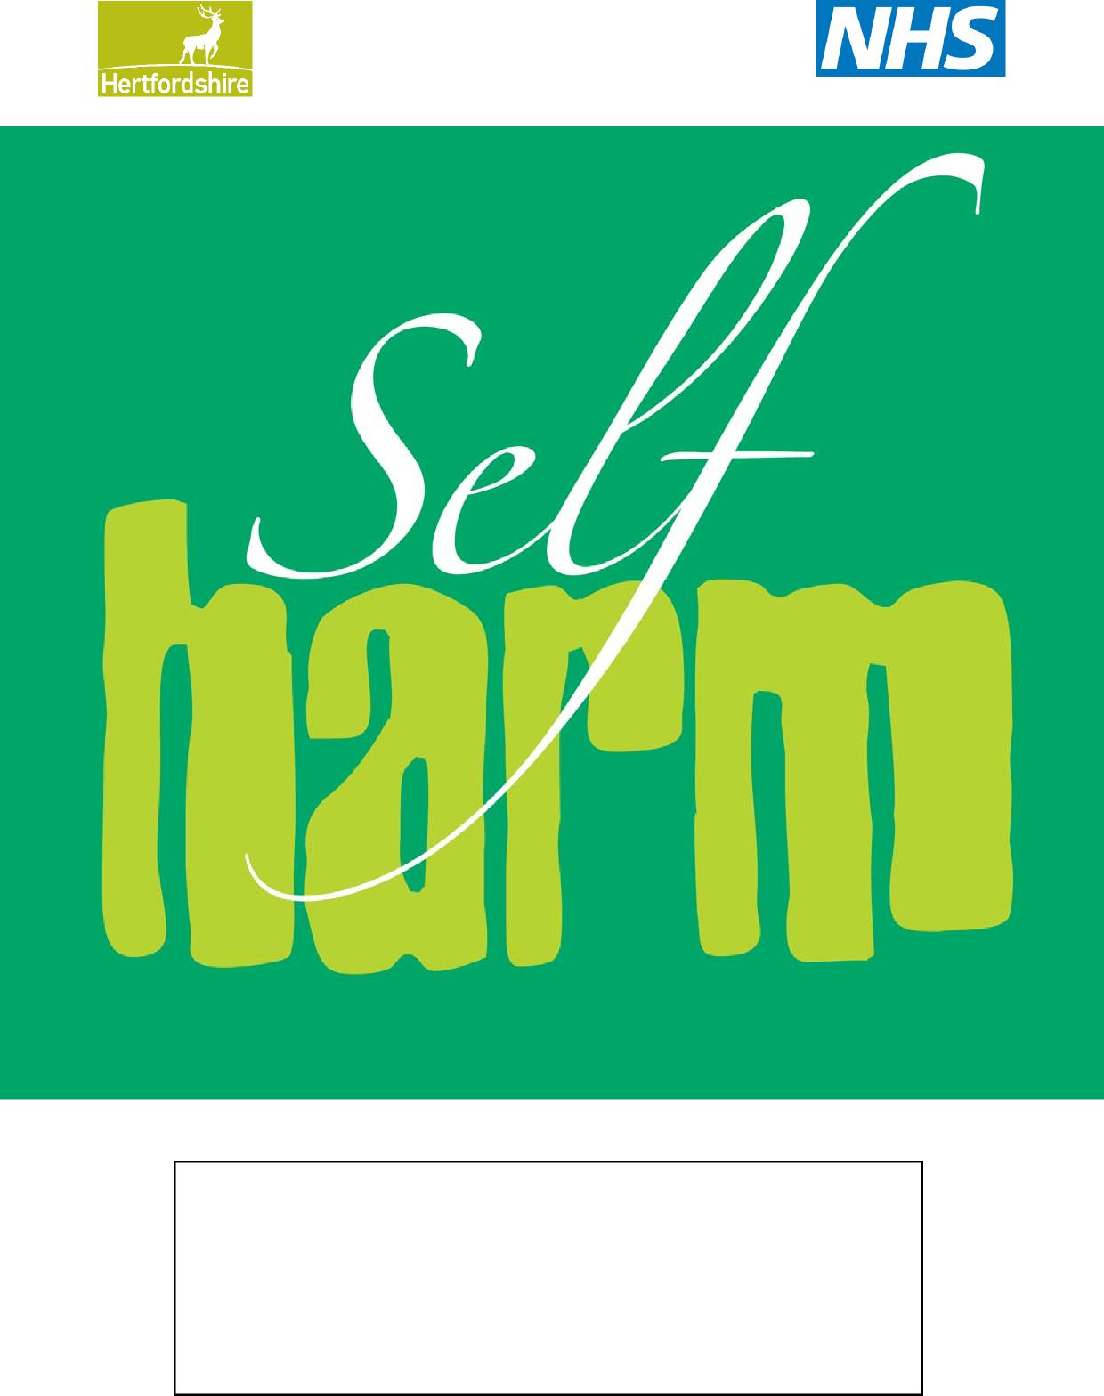

Self-harm

Information for school staff in Hertfordshire

Adapted from resources created by the Oxfordshire Adolescent Self Harm Forum

**Self-Harm**

**Contents *Page***

3. What is self-harm and how common is it?

4. What causes self-harm

4. Risk factors

4. Triggers

5. Warning signs

5. Examples of self-harming behavior

5. What keeps self-harm going

6. The cycle of self-harm/cutting

6. Coping strategies

8. Reaction of school staff

8-9. How to help within schools – step-by-step guide

Information for school staff in Hertfordshire

This information leaflet is intended to help school staff to understand more about self harm and be able to support young people who harm themselves.

This information should be read in conjunction with the Hertfordshire Safeguarding Children’s Board procedures in relation to self harm and suicide:

http://hertsscb.proceduresonline.com/chapters/p_self_harm.html

Further resources to help schools to support pupils who self harm can be found here:

https://www.healthyyoungmindsinherts.org.uk/self-harm-toolkit

**What is self-harm and how common is it?**

Self-harm is any behaviour such as self-cutting, swallowing objects, taking an overdose, hanging or running in front of cars etc., where the intent is to deliberately cause self-harm.

Some people who self-harm have a strong desire to kill themselves. However, there are other factors which motivate people to self-harm including a desire to escape an unbearable situation or intolerable emotional pain, to reduce tension, to express hostility, to induce guilt or to increase caring from others. Even if the intent to die is not high, self-harming behaviour may express a powerful sense of despair and needs to be taken seriously. Moreover, some people who do not intend to kill themselves may do so, because they do not realise the seriousness of the method they have chosen or because they do not get help in time.

Over the last 40 years there has been a large increase in the number of young people who deliberately harm themselves. A large community study in the UK found that in 15-16 year olds, approximately 6.9% of young people (3.2% males and 11.2% females) had self-harmed in the last year.

*See Hawton et al. (2002) Deliberate self harm in adolescents: self report survey in schools in England. BMJ, 325, 1297-1211.*

What causes self-harm?

**Risk Factors**

The following risk factors, particularly in combination, may make a young person vulnerable to self-harm:

**Individual factors**

* depression/anxiety
* poor communication skills
* low self esteem
* poor problem solving skills
* hopelessness
* impulsivity
* drug or alcohol abuse

**Family factors**

* unreasonable expectations
* abuse (physical, sexual, emotional or neglect)
* poor parental relationships and arguments
* depression, deliberate self-harm, suicide or other mental health difficulties in the family
* drug/alcohol misuse in the family
* domestic violence

**Social factors**

* difficulty in making relationships/ loneliness
* persistent bullying or peer rejection
* easy availability of drugs,
* medication or other methods of self-harm

The pressures for some groups of young people and in some specific settings may increase the risk of self-harm:

* young people in residential settings (e.g. inpatient units, prison, sheltered housing or hostels or boarding schools)
* young people with mental health difficulties
* young people who are lesbian, gay, bisexual or transgender and who feel isolated and unsupported
* some young people may access internet sites relating to self-harm, some of which may be helpful but others may increase the risk of self-harm by promoting different methods and normalising self-harm.

**Triggers**

A number of factors may **trigger** the self harm incident:

* family relationship difficulties **(the most common trigger for younger adolescents)**
* difficulties with peer relationships e.g. break up of relationship **(the most common trigger for older adolescents)**
* bullying/cyberbullying
* significant trauma e.g.   
  bereavement, abuse
* child sexual exploitation
* self-harm behaviour in other students (contagion effect)
* identification with a peer group which promotes self-harm
* self-harm portrayed or reported in the media
* difficult times of the year (e.g. anniversaries)
* trouble in school or with the police
* feeling under pressure from families, school and peers to conform/achieve
* exam pressure
* times of change (e.g. parental separation/divorce)

**Warning signs**

There may be changes in the **behaviour** of the young person which are associated with self-harm or other serious emotional difficulties:

* changes in eating/sleeping habits
* increased isolation from friends/family
* excessive and secretive use of the internet
* changes in activity and mood e.g. more aggressive than usual
* lowering of academic grades
* talking about self-harming or suicide
* abusing drugs or alcohol
* becoming socially withdrawn
* expressing feelings of failure, uselessness or loss of hope
* giving away possessions

**Examples of self-harming behaviour**

* cutting
* taking an overdose of tablets
* swallowing hazardous materials or substances
* burning – either physically or chemically
* over/under medicating e.g. misuse of insulin
* punching/hitting/bruising
* hair pulling/skin picking/head banging
* episodes of alcohol/drug/substance misuse or over/under eating can at times be acts of deliberate self-harm
* risk-taking behaviours may be acts of deliberate self-harm

Self-harm can be a transient behaviour in young people that is triggered by particular stresses and resolves fairly quickly, or it may be part of a longer term pattern of behaviour that is associated with more serious emotional/psychiatric difficulty. Where there are a number of underlying risk factors present, the risk of further self-harm is greater.

**N.B.** Some young people get caught up in mild repetitive self-harm such as scratching, which is often done in a peer group. In this case it may be helpful to take a low-key approach, avoiding escalation, while at the same time being vigilant for signs of more serious self-harm.

**What keeps self-harm going?**

Once self-harm (particularly cutting) is established, it may be difficult to stop. Self -arm can have a number of functions for the young person and it becomes a way of coping.

**Examples of functions include**

* Reduction in tension (safety valve)
* Distraction from problems
* Form of escape
* Outlet for anger and rage
* Opportunity to feel physical pain to distract from emotional pain
* Way of punishing self or others
* Way of taking control
* Care-eliciting behaviour
* A means of getting identity with a peer group
* Non-verbal communication (e.g. of abusive situation)
* It can also be a suicidal act

The cycle of self-harm/cutting

When a person inflicts pain upon himself or herself the body responds by producing endorphins, a natural pain reliever that gives

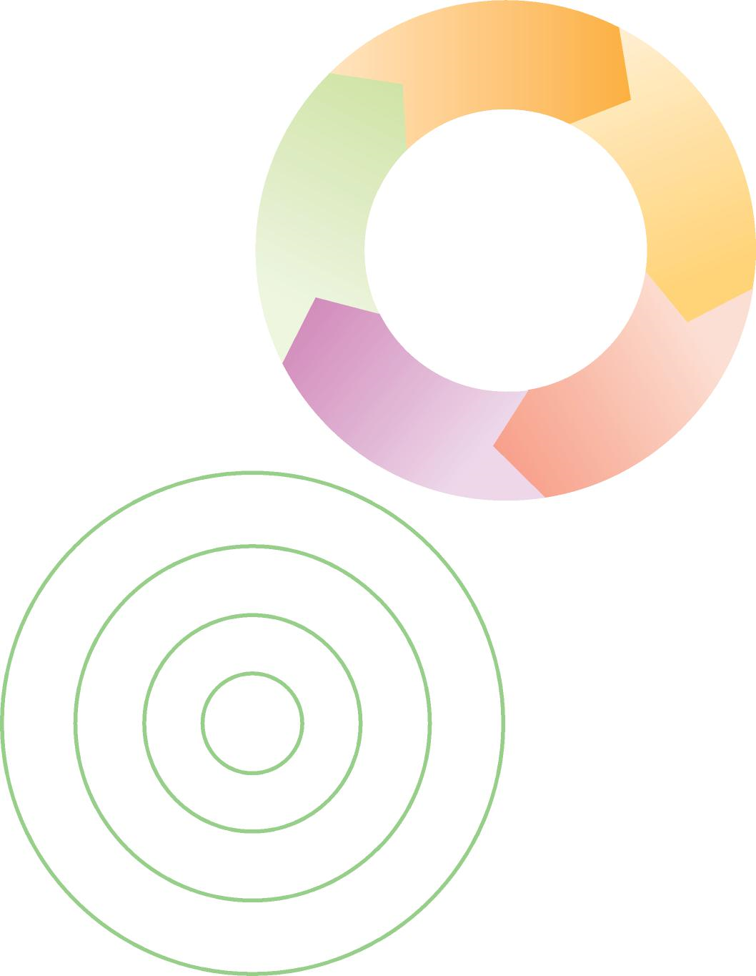temporary relief or a feeling of peace.   
The addictive nature of this feeling   
can make self-harm difficult to stop.

**Negative emotions**

Sadness, anger, despair

Young people who self-harm   
still feel pain, but some say   
the physical pain is easier   
to stand than the   
emotional/mental pain   
that initially led to the   
self-harm.

**Tension**

Inability to control emotions, maybe using dissociation to cope with tension

**Negative effects**

Shame and guilt over   
self-harm   
act

Coping strategies

1 **Using support networks**

It is helpful to identify who   
can support the young person   
and how to get in touch with them.   
Examples are friends, family,   
school teacher, counsellor.   
Knowing how to access crisis support   
is also important.

**Social Worker**

**Positive Effects**

Endorphins released,   
 tension and negative   
 feelings dispelled   
 for a short   
 period

**Self-harm act** Cutting, burning

etc.

**Therapist**

**School Counsellor**

**Dance teacher**

**Best friend**

**Aunt**

**Me**

**Mum**

**Sister**

2 **Distraction Activities**

Replacing the cutting or other self-harm with other safer activities can be a positive way of coping with the tension. What works depends on the reasons behind the self-harm.

Activities that involve the emotions intensely can be helpful

**Examples of distraction methods:**

* Contacting a friend or family member
* Going for a walk/run or other forms of physical exercise
* Getting out of the house and going to a public place e.g. a cinema
* Reading a book
* Keeping a diary
* Looking after an animal
* Watching TV
* Listening to music

**THINGS I CAN DO MYSELF TO COPE WITH DIFFICULT FEELINGS:**

* Ring my friend up
* Have a relaxing bath
* Watch a film on TV
* Go for a walk
* Write down my feelings
* Listen to my favourite music

**3 Coping with distress using self-soothing**

* Using stress management techniques such as relaxation
* Having a bubble bath
* Stroking a cat or other animal
* Going to the park and looking at the things around you (birds, flowers, trees)
* Listening to the sounds as you walk
* Listening to soothing music

**4 Discharging unpleasant emotions in other ways**

Sometimes it can be helpful to find other ways of discharging emotion which is less harmful than self-harm:

* Clenching ice cubes in the hand until they melt – this can relieve some tension
* Writing, drawing and talking about feelings
* Writing a letter expressing feelings, which need not be sent
* Going into a field and screaming
* Hitting a pillow /soft object
* Listening to loud music
* Physical exercise can be a good way to discharge emotion

**In the longer term** a young person may need to develop ways of understanding and dealing with the underlying emotions and beliefs. Regular counselling/therapy may be helpful. Family support is likely to be an important part of this.

It may also help if the young person joins a group activity such as a youth club, a keep fit class or a school based club that will provide opportunities for them to develop friendships and feel better about themselves. Learning stress management techniques, ways to keep safe and how to relax may also be useful.

Reactions of school staff

Staff may experience a range of feelings in response to self-harm in a young person (e.g. anger, sadness, shock, disbelief, guilt, helplessness, disgust or rejection). It is important for all work colleagues to have an opportunity to discuss the impact that self-harm has on them personally. The type and nature of the forums where these issues are discussed may vary between settings.

In schools young people may present with injuries to first aid or reception staff. It is important that these frontline staff are aware that an injury may be self-inflicted, that they know how to support and assess a person presenting with self harm and that they pass on any concerns.

Other considerations

Consider a uniform policy which allows for long sleeves during summer and winter and a PE kit which allow arms and legs to be covered. If requested by a young person, consider providing an individual area for PE changing. Ensure that school trip leaders are made aware of pupils who self harm so they can be adequately supported.

How to help within schools – a step by step guide

If a member of staff is informed about, or discovers a student with problem, it is important that they talk to the young person to determine physical first aid requirements and risk [(Use HSCB guidance).](http://hertsscb.proceduresonline.com/chapters/p_self_harm.html) Engaging with the young person in a caring conversational style is a better way of doing this than approaching the situation in a medical checklist-type way. See [‘Talking to young people who are self harming’](https://www.healthyyoungmindsinherts.org.uk/publications/2018/apr/responding-self-harm-school-staff).

It is important that all attempts of suicide or self-harm are taken seriously. All mention of suicidal thoughts should be noted and the young person listened to carefully.

If a young person has serious physical injuries, has taken an overdose or is at high risk of suicide, the young person must attend A&E (parents can take their child or an ambulance may be called depending on the circumstances).

In an emergency, the Designated Safeguarding Person (DSP) must be advised immediately. If the risk does not require emergency intervention listen non-judgmentally. Try to reassure them that you understand that self-harm is helping them to cope at the moment and you want to help them.

Discuss confidentiality. Depending on the policy in your school, you may need to share information with the DSP and / or Mental Health Lead. It is important that any member of staff that a young person has sought support from is supported to continue to provide support to the young person if they feel able to. It is also important that Safeguarding or Mental Health leads have an oversight of young people engaged in self harm within the school.

Try to build a picture of the young person’s life through a conversational approach, it may help to walk together or engage in another activity whilst talking to reduce the pressure. Record key information about your judgements in relation to actions you have taken and the young person’s wishes.

Ensure the young person feels empowered in the choices around next steps. They may not have a choice in some actions but they may have a choice about how these take place, eg you may need to pass on the information to the DSP but the young person could be offered the choice about whether you do this together or not.

Discuss with the young person the importance of letting parents know and listen to any fears they have about this. Discuss how they would like this to happen; they may wish to tell them themselves or they may wish to do it with your support.

Contact parents (unless there are particular reasons why they should not be contacted) and discuss the school’s concern. Help the parents to understand the self-harm so that they can be supportive to the young person. You can use the meeting [follow up letter](https://www.healthyyoungmindsinherts.org.uk/publications/2018/apr/responding-self-harm-school-staff) and the [information leaflet for parents](https://www.healthyyoungmindsinherts.org.uk/publications/2018/apr/responding-self-harm-school-staff). Remember, a parent may experience a range of emotions after initially finding out about their child’s self-harm and they may need some time to process the information.

What appears to be important for many young people is having someone to talk to, who listens properly and does not judge. This person may be a mentor, youth worker, school health nurse, teacher etc. Establishing a support network with the young person should be considered as well as school based support that may be available such as a counsellor. Ensure the young person has access to the [signposting guide.](https://www.healthyyoungmindsinherts.org.uk/publications/2018/apr/signposting-guide-young-people)

Consider a referral to a child and adolescent mental health service if there are associated mental health issues. You can [contact the Single Point of Access for advice](https://www.healthyyoungmindsinherts.org.uk/professionals/making-referral) and make a referral directly [using this form](https://www.healthyyoungmindsinherts.org.uk/publications/2017/jul/multi-service-camhs-referral-form). Parents and the young person need to consent to this. If they are more comfortable going to the GP, you can [complete the school information form](https://www.healthyyoungmindsinherts.org.uk/publications/2017/nov/school-information-form) to advise the GP of your concerns so they can make a robust referral.

Social work colleagues in Children's Services should be informed if what the young person says or does raises child protection concerns, use the Hertfordshire Child Protection referral form or ring 0300 123 4043. Document any conversations you have had with the social worker and any advice they have given you to follow. Self-harm, itself can be considered a safeguarding issue either if is serious or if parents are not addressing it adequately. You may consider making a Families First referral.

If other agencies are already involved with the young person then it may be important to liaise with these agencies and work together.

Continue to treat the young person with unconditional positive regard, record any incidents or changes in risk, monitor outcomes of interventions and consider other options where needed. Ensure that support for staff involved is facilitated.

Ensure your whole school approach is robust. A [self review tool](https://www.healthyyoungmindsinherts.org.uk/publications/2017/nov/hertfordshire-schools-self-review-whole-school-approach-mental-health-and) is one of many resources available to mental health leads and other staff in school on the healthyyoungmindsinherts.org.uk website. You can register for access to the online [toolkit](https://www.healthyyoungmindsinherts.org.uk/schools/mental-health-leads-toolkit) here:

<https://www.healthyyoungmindsinherts.org.uk/user/register>

Staff wellbeing

School staff need to look after their own mental health and wellbeing. For practical early help, anyone over the age of 16 registered to a GP in Hertfordshire can self refer to the NHS Wellbeing Service via this website:

[www.talkwellbeing.co.uk](http://www.talkwellbeing.co.uk)